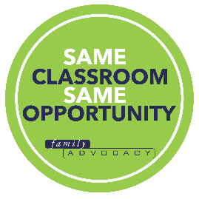

Suite 704, 88-90 George Street,
Hornsby, NSW, 2077, Australia

<ELECTORATE OFFICE ADDRESS>

<DATE>

Dear <Mr/Ms MP NAME>,

Re: Inclusive education for all NSW children

I am a local constituent and I am writing to seek a meeting with you regarding inclusive education.

No matter our differences, we all want to know that we belong and have access to the same opportunities as our peers. However, the current system of segregating children with disabilities guarantees that some children are missing out. For example, Tim who has Down Syndrome, is led away from his friends to a separate classroom every day and not included in school camp – a constant reminder of the ways he’s different when really he’s just like other children. We all want to feel like we belong.

My family is just one of many affected by this issue. In fact, segregation of students with disability has increased significantly over the past decade as has home schooling. Students with disability are experiencing disturbing rates of bullying, situations of restraint and seclusion, and are overrepresented in suspension statistics. Also, the statistics are even worse for indigenous students, where the rate of disability is twice as high.

Inclusive education means having all children in the same classroom, with access to the same opportunities. This approach benefits all children – those with and those without disability; and it lays the foundation for strong communities that value diversity and ensures social cohesion.

Everyone deserves a fair chance to fulfil their potential and that’s why we need inclusive education for all children in NSW.

I look forward to meeting and discussing this issue with you.

Kind Regards,

<SENDER FULL NAME>

